Storage System for Small documents (B2B-IEP)
Project.
User Requirement Specification (URS)

Document Reference:
Project: | B2B-IEP
Document Title: | Storage System for Small documents
Version: | 1.0
Prepared by: | Karen Gao
Approved by :
 | Sui Haiyang |  | Date
 | Project Manager |  | ?? March 2008
Approved by :
 | Mr. M. Sakthivel PMP |  | Date
 | User Representative
© 2009  The information contained in this document is the property of ISS. The contents must not be copied in whole or in part for purposes other than which it has been supplied without the consent of ISS, or, if it has been furnished under contract to another party, as expressly authorised under that contract, then ISS shall not be liable for any errors or omissions. |  | 
Institute of Systems Science, 25 Heng Mui Keng Terrace,
Singapore 119615

Version History Record
Document Reference: /B2B-IEP/URS
Version | Date | Brief description of amendments and affected pages, paragraph
1.0 | 18/03/09 | Draft Issue

Distribution:

Name | Department | Organisation
ISS Audit | ISS | ISS
Sui Haiyang | Project Manager | ISS-SE16S07
Gao Jia Si Karen | Document Manager / Developer | ISS-SE16S07
Yap Sie Kuok, Thomas | Document / Quality Executive | ISS-SE16S07
May Ann Sallan | Quality Manager / Developer | ISS-SE16S07
Rajendran Kumaraguru | Database Designer / Developer | ISS-SE16S07
Kumarasamy Shanmugam | Technical Lead | ISS-SE16S07
Thiyagarajan Ravikumar | Development leader | ISS-SE16S07

PROJECT REPORT
A STORAGE SYSTEM FOR SMALL DOCUMENTS

Submitted by
SE16 – Team 7S
Team Members:
Matric Number | Name
g0702197 | Bipin Johnson
g0702239 | Rahul Zilpe
g0702211 | Gao Jia Si, Karen
g0702273 | Sui Haiyang
g0702248 | May Ann Sallan
g0702259 | Thiyagarajan Ravikumar
g0702260 | Yap Sie Kuok, Thomas


In partial fulfilment of the requirements
for the Master of Technology on Software Engineering
Institute of System Science
National University of Singapore

ABSTRACT

The Storage System for Small Documents is an integrated database managing and search engine, which was mainly developed for small documents. It was created by using object-oriented program approach.

The Storage system can do the following:
- to manage all information stored in the database by means of adding, deleting, and compacting
- search and display a set of documents with that matched word/s keyed by the user
- index documents through the use of lucene

The application was developed using Java sdk library, and lucene, a high-performance, full-featured text search engine library.

In this report, the specification requirements analysis, design procedures, and performance evaluation for development of Storage System for Small Documents are presented as well.

ACKNOWLEDGMENTS

We would like to express our heartfelt thanks to our subject Lecturer Mr. Miotto, Olivo for his invaluable teaching and guidance on the theoretical aspects of project design.

We would also like to show our appreciation and big thanks to our dear project group mates, who work hard on the design and coding until midnight despite the heavy workload during normal working days. Without their great efforts, this project wouldn’t be successfully completed.

Last but not least, special mention must be given to those lovely family members and colleagues who give us support during our study and project work.
CONTENTS
ABSTRACT i
ACKNOWLEDGMENTS ii
List of Figures iii
List of Tables iii
Chapter 1 INTRODUCTION 1
1.1 Objective 1
1.2 Assumptions for the Storage System 1
1.3 Software Overview 1
1.4 Summary of Achievement for the Storage System 2
1.5 Organization of the Project Report 2
Chapter 2 PROJECT SCOPE 4
2.1 Project Plan 4
2.2 Project Role Delegation 4
Chapter 3 SOFTWARE SPECIFICATION REQUIREMENTS ANALYSIS 6
3.1 Analysis of Specification and Requirements 6
3.2 Risk Analysis 7
Chapter 4 SOFTWARE DESIGN ON STORAGE SYSTEM (Pending for Update) 9
4.1 Design Overview 9
4.2 Design Procedure 9
4.3 UML Class Diagram 10
4.3.1 BSED Commons 10
4.3.2 Common Config 10
4.3.3 Application Properties 10
4.3.4 Properties Manager 10
4.3.5 Properties Manager 10
4.3.6 BSED Database 10
4.3.7 File Base Store 10
4.3.8 Document Store 10
4.3.9 File Document Store 10
4.3.10 File Text Store 10
4.3.11 Text Store 10
4.3.12 Constant 10
4.3.13 Separator Tokenizer 10
4.3.14 BSED File Helper 10
4.3.15 BSED GUI 11
4.4 Description of Application Features 11
4.5 Description of GUI 11
4.5.1 Menu Bar 12
4.5.2 Search Panel 14
4.5.3 Text Display Panel 15
4.5.4 Status Bar Panel 17
4.6 Description of Additional Features 17
4.6.1 Support of Alternative File Implementation 17
4.6.2 Search Engine Support 18
Chapter 5 SOFTWARE TESTING 19
5.1 Test Plan 19
5.2 Test Results 19
Chapter 6 EVALUATION AND RECOMMENDATIONS 21
6.1 Design and Performance Evaluation 21
6.2 Recommendations for Future Development 22
Chapter 7 CONCLUSION 23
REFERENCES 1
Appendix A - Source Codes for Storage System 2
Appendix B – Testing Documents 2

List of Figures
Figure 1.1 Overview Software Design Flowcharts (Pending for Update) 1
Figure 4.1 Software Structure 9
Figure 4.2 Design Process Flow Chat 9
Figure 4.3 Design Block Diagram 9
Figure 4.2 GUI of Text Store Viewers – Team S07 12
Figure 4.3 Menu Bar of GUI 13
Figure 4.4 Search Panel of GUI 14
Figure 4.5 Text Display Panel of GUI 15
Figure 4.6 Input Message of GUI 16
Figure 4.7 Save Confirmation Message of GUI 16
Figure 4.8 Save Confirmation Message of GUI 16
Figure 4.8 Delete Confirmation Message of GUI 17
Figure 4.9 Status Bar Panel of GUI 17

List of Tables
Table 2.1 Project Role Delegation with dateline 4
Table 3.1 Specification and Requirements Analysis 6
Table 3.1 Risk Analysis (Pending for Update) 7
Table 4.1 Functionalities of Menu 13
Table 5.1 Test Plan table 19
Table 5.2 Description on Test Results 19

INTRODUCTION

Objective
The objective of this project is to design and develop a Storage System for Small Documents, which is an integrated database managing and search engine for large numbers of small files, and being able to support reading and writing of records. This was presented in a user-friendly Graphical Interface.

The Storage system was created using java, an object-oriented programming language.

Assumptions for the Storage System
The Storage System design is assumed as a single – user model, and it would not be supporting multi-user environment transactions.

Software Overview
(Pending for Update)

Figure 1.1 Overview Software Design Flowcharts (Pending for Update)

Summary of Achievement for the Storage System
With the specifications required in the assignment hand out, this Storage System is able to satisfy and meet the fundamental implementation of the database system. A specialised implementation for storing text documents and a user friendly interface for searching and managing the database were successfully created.

The superiority in this Storage System to others with similar functionalities, is the text search Engine Support from Lucene. In addition, this system allows the users to select at random the required documents.

Organization of the Project Report
- Chapter 1 provides the objective of this storage system for small documents design project. The problems solved and achievements for this project are also summarised.
- Chapter 2 gives a brief explanation on project plan, as well as project role delegation for group.
- Chapter 3 analyses the software specification requirements. Project risk analysis is also discussed in this chapter.
- Chapter 4 deals with the software implementation and shows the structure of software by using simple UML class diagram. The fundamental features and some of additional features are described as well as the GUI.
- Chapter 5 describes the software test plan and test results.
- Chapter 6 evaluates the Storage System Design and performance. Some recommendations for future development are also discussed.
- Chapter 7 concludes the whole project and report with some discussions.

PROJECT SCOPE

Project Plan
Project Plan for the design and development of Storage System for Small documents were finalized during first group meeting by team members. Team organization and creation of project specification were defined for better communication and project deliverables.

Project Role Delegation
Project Roles for each team members according their preference and interests were also delegated. The table 2.1 summarised the task assigned to each team members with dateline.

Table 2.1 Project Role Delegation with dateline

Item# | Scope/Task | Assigned to | Dateline
1 | Requirements Analysis | All | 3/29/2008
2 | Design | All | 3/29/2008
3 | RAD Documentation | Karen | 3/29/2008
4 | - Base class & method | Ravi | 3/29/2008
5 | - Coding Style/Standard | Ravi | 3/29/2008
6 | - UML | Karen | 3/29/2008
7 | Flat Datastore creation | Rahul/May/HaiYang/Ravi | 3/29/2008
8 | Coding | - | 3/29/2008
9 | - Ravi (GUI and Integration) | Ravi | -
10 | - May (DB creation & Compact) | May | -
11 | - HaiYang (Search & DB Maintenance) | HaiYang | -
12 | - HaiYang (Maintenance) | HaiYang | -
13 | Code Review | All | 3/29/2008
14 | Unit Testing | - | 3/29/2008
15 | - Ravi | Ravi | -
16 | - May | May | -
17 | - HaiYang | HaiYang | -
18 | - Rahul | Rahul | -
19 | Integrated Testing | - | 4/5/2008
20 | - Ravi | Ravi | -
21 | - May | May | -
22 | - HaiYang | HaiYang | -
23 | - Rahul | Rahul | -
24 | - Thomas | Thomas | -
25 | - Karen | Karen | -
26 | - Bipin | Bipin | -
27 | Project Report - report.doc | Karen | 4/5/2008
28 | Collection of packages | Thomas | 4/5/2008
29 | Submission | Thomas | 4/7/2008

SOFTWARE SPECIFICATION REQUIREMENTS ANALYSIS

Analysis of Specification and Requirements
The given software specifications and requirements in the assignment paper were analyzed and interpreted into three categories, which include fundamental implementation requirements, GUI requirements and additional requirements. Due to the time constraint, there are two additional requirements chosen to be fulfilled in this project in order to enhance the application through the team analyze and discuss.
Those requirements were listed as table 3.1.

Table 3.1 Specification and Requirements Analysis

S/No. | Items Description
 | Category ONE: Fundamental Requirements
1 | Import data text files into the database for storage
2 | Add document
3 | Remove document
4 | Get Document based on key
5 | Get all the key names
6 | Extended functionality for importing text data files.
 | Category TWO: GUI Design Requirements (Text Store Viewer) -- for searching & managing the database
1 | Open a database at a given location (folder, constructor argument for FileStore)
2 | Search the document, given a key.
3 | Search the list of documents, given a search string
4 | Given a key, upon selecting the key retrieve the document & display the contents.
5 | Create a new document, with an arbitrary key, edit & store.
6 | Delete or modify selected document & store it subsequently.
7 | Import multiple files into the database using file name as key.
8 | Given a selected list of keys, store the documents into files in a given folder with the key as a file name (Multiple Exporting)
9 | Compact the database.
 | Category THREE: Additional Requirements
1 | Support for alternative file system implementation and performance improvement for Java Random Access files
2 | Use of Third party search engine - Lucene

Risk Analysis
Some critical points may influence the software design and performances were identified during the requirements analysing stage. Their corresponding solutions were discussed and applied.

Table 3.1 Risk Analysis (Pending for Update)

S/No. | Identified Risk | Solution Applied | Rational
1 | Concurrent access of the file | Single User Model | As Specification stated
2 | Retrieving methods | Data retrieved should be cached | Allow subsequent retrieval of the same record to be faster
3 | Documents exporting, the existing files in the folder may be overwritten | Listed out the existing documents, and keep it untouched. | Exported files are stored into database according to its index in memory.
4 | To physically remove the documents from database frequently will affect the performance | Mark the index of the document as "deleted", and only physically remove the requiring deleted files during compacting. | Reasonable Improvement on the performance, physically removal according to documents' indexes.

SOFTWARE DESIGN ON STORAGE SYSTEM (Pending for Update)

Design Overview
The overall structure of this program shows as figure 4.1, which gives the idea of how the programming organized.

Figure 4.1 Software Structure

Design Procedure
The design flow of this program shows in figure 4.2. It shows that how the whole program algorithm is iterating.

Figure 4.2 Design Process Flow Chat

This block diagram of design shows that general design procedures with the most important parameters needed for a BLDC motor design.

Figure 4.3 Design Block Diagram

UML Class Diagram

BSED Commons

Common Config

Application Properties

Properties Manager

Properties Manager

BSED Database

File Base Store

Document Store

File Document Store

File Text Store

Text Store

Constant

Separator Tokenizer

BSED File Helper

BSED GUI

Description of Application Features
The main feature of the storage system is to manage any selected database for the purpose of reading, writing, retrieving, editing and deleting the small documents in both binary object as well as text file. This feature was achieved by using the conversion of text file into bytes for the read/write operation to the database. All of the document contents are retrieved / inserted as a byte array or string. A flat-file database with Lucene search engine for this application was implemented.

Description of GUI
The GUI named as Text Store Viewer was designed as a user start interface window to the management and search functionality of the database according to the requirements of the project.

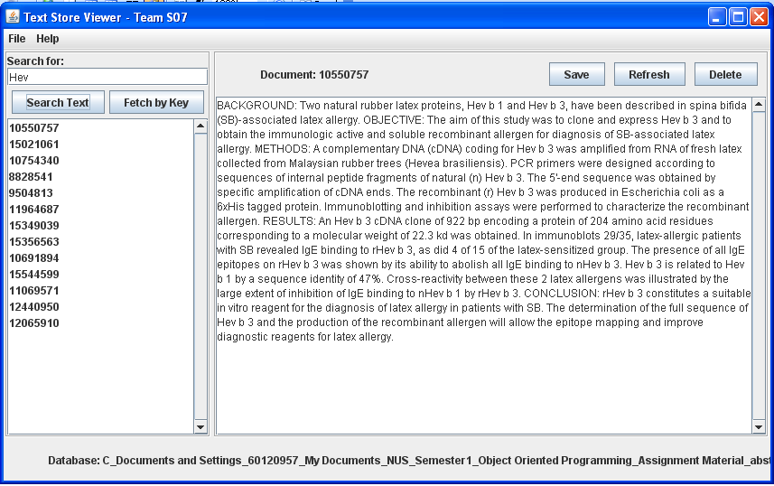
Status Bar

Menu Bar

Search Panel

Text Display Panel

Menu Bar

Menu Bar

Figure 4.2 GUI of Text Store Viewers – Team S07

Four main different panels were designed for The GUI of Text Store viewer window:
- Menu Bar
- Search Panel
- Text Display Panel
- Status Bar

Menu Bar
The Menu Bar designed for the user interface consists of TWO groups of function managements:
- File Menu - This menu deals with the Database operations, such as create a new database, open an existing database, compact a database and import the existing files.
- Help Menu - This menu shows that the operations of GUI functionalities and the application version information.

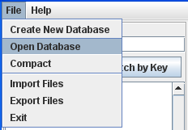
Figure 4.3 Menu Bar of GUI
The detail functionalities of each menu are summarized in Table 4.1.
Table 4.2 Functionalities of Menu
S/No. | Menu |  | Description
S/No. | Level 1 | Level 2 | Description
1 | File | Create New Database | This will open up a "File Open Dialog box" for user to select a “Folder”, which the set of text files are located, and the database for this set of text files will be created and located automatically into C:\Database
1 | File | Open Database | This will open up a "File Open Dialog box" and directly point to a defaulted directory C:\Database for user to select a existed database
1 | File | Compact | This function is used to de-fragment a selected database, therefore to achieve a purpose of minimizing the amount of empty space between documents. The compacting time may varies depends on the database size.
1 | File | Import Files | This function is used to Import text/binary files to current database from a specified folder. Importing of Multiple files is allowed. Once file imported, it will be showed after refresh.
1 | File | Export Files | This function is used to export user-selected files from the current data base to a specified folder by selecting the folder location in "Open Dialog box". Exporting of Multiple files is allowed.
1 | File | Exit | This function is simply used for proper application exit. User is given a choice to save his edited text if any at the time of exiting.
2 | Help | Help | It will show the operations of GUI functionalities, User could seek the help on the functions available for the designed User Interface
2 | Help | About Text Store Viewer | It will show the current version for Text Store Viewer application.

Search Panel
Search panel consists of two Sub–panels, which include Sub-Search and Key Index (File Name) List Panel.
Sub-Search Panel
Key Index (File Name) List Panel
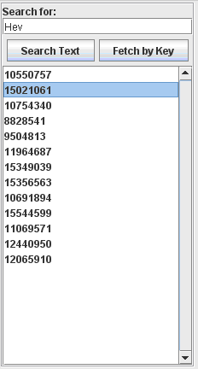
Figure 4.4 Search Panel of GUI

Sub-Search panel is used to provide search functions for the user, in where the user could choose search a document by its file name or contents from a selected database. The search function is executed by TWO methods, one is Search Text and another is Fetch by Key.
- Search Text: This method allows the user to search and retrieve a list of documents that contains the searched contents in text format. What the user needs to do is to simply key in any or any combination of alphabets which the user is searching for.
- Fetch by Key: user can type in few starting letter(s) of the document key. Upon clicking the “Key Search” button, a list of all the keys containing these letters will be displayed in the key list.
Once the search function executed, the searched results will be displayed in the Key Index (File Name) List panel if it is not empty in the particular searched database. Upon double clicking on the file name, the full content of selected text file will be displayed in to Text Display Panel. Multiple files are allowed be highlighted and exported.

With a given key (file name) of the document, searched results will return the string content of the document behind the GUI level but display in text format in GUI level. There is three possible results for text searching will be listed out depends on the search query written.

- “a AND b”: the content of searched results will contain both a and b words.
- “a OR b” :
- “a NOT b”:

Text Display Panel
The Text Display Panel consists of document key, text display area and document management buttons.
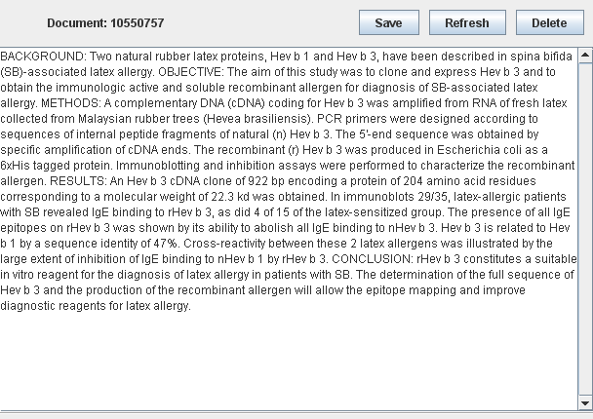
Figure 4.5 Text Display Panel of GUI

- Document Key: is used to display the file name for the selected document.
- Text display area: is used to display the text contents for the selected document.
- Document management buttons:
Three document management buttons are designed.
Save: User can edit the existing text or create a text file in a currently opened database, and use this save button to keep the modified or created contents into the Database. Saving modified file will require user enter file name as the KEY into an “Input” message box, while creating a new text file will prompt the confirmation message box to acquire the acknowledgement of user.
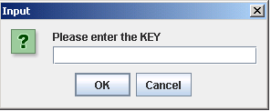
Figure 4.6 Input Message of GUI

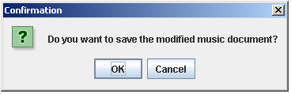
Figure 4.7 Save Confirmation Message of GUI

Refresh: This button is to provide a way to undo currently edited file and empty the Text Display Area for creating a new document. Therefore, a prompt message to confirm the action is provided.
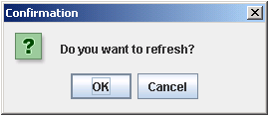
Figure 4.8 Save Confirmation Message of GUI

Delete: This button is used to delete a selected document from the currently opened database, and a confirmation of deleting message will prompt out before its operation is executed actually.
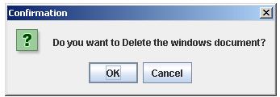
Figure 4.8 Delete Confirmation Message of GUI

Status Bar Panel
The status bar located at the bottom of the main screen, which shows the currently opened data location in the operating system.

Figure 4.9 Status Bar Panel of GUI

Description of Additional Features

In order to enhance the operation of the Storage System application, two addition features are implemented, which are described as below.

Support of Alternative File Implementation

In order to speed up and achieve a better I/O performance, we introduce the concept of caching the data after it was retrieved so that there isn’t a need to execute another IO when the user requests the same record. Imagero Unified I/O as an alternative for random file access file in our program is configured in the properties file. With this, files in the database do not need to go through sequence & access directly the specified file.

Search Engine Support

Lucene was used as our search engine for the text searching mechanism. Detailed research on its implementation was made in the earlier stage of project design. Lucene search engine in this project is to treat each record as a document (Lucene’s context) and pass it to Lucene for indexing.

According to the research, Lucene doesn't support updating indexes directly, and the performance of using Lucene’s indexing of documents for searching is an expensive process. In order to overcome this deficiency, the concept of updating Lucene in a batch method was introduced.

The approach to create index in Lucene is firstly get the document tiles represented in a given key, then the current length of database is obtained to get a start point of a new document, the following step is to catch the length and binary content of the document, and the status of document if it is marked in deleted. During the database updating, a document with a given key and binary content will be added to the tail of database with a created new index. To compact a database is to create a temperate file and write only the documents that are not marked as deleted, also update the index with the appropriate details.

This improves the performance significantly when compared to the first attempt of introducing Lucene into this project.

In order to ensure that the index’s self-index is synchronized with the content of the database, Lucene are invoked whenever there is an operation of insertion, updating or deletion occurred. Although this translates into increased I/O time, but it is not considered as significant as the update takes once for one record at a time. Furthermore, any or any combination of alphabets searching is all void in this application.

SOFTWARE TESTING

Test Plan
The application has been tested to ensure the proper functionality, robustness and performance. The final version of the application was tested based on the software requirements to make sure that all the necessary requirements have been included in the project. The table 5.1 given below includes the major areas where testing was carried out.
Table 5.3 Test Plan table

S/No. | Test Cases: | Status | Remarks
1) | Create a new database from a folder (importing all the text file from that folder) and save to C:\databases folder | Yes | Assuming that the files name are in small cap and no space in between.
2) | Open an existing database from c:\databases folder | Yes
3) | Search the database for a document, given a key | Yes
4) | Search the database for a list of documents, given a search string | Yes
5) | Given a list of documents, select the document (key) and the document is retrieve and displayed in a text editor | Yes
6) | Create a new document, with an arbitrary key, edit and store it | Yes
7) | Delete a selected document | Yes | not consistent
8) | Modify a document and store it | Yes
9) | Import multiple files into the database, using the file name as key | Yes
10) | Given a selected list of keys, store them into files in a chosen folder using the key as filename | Yes | The contents repeat itself a few times
11) | Compact the database and open the database to verify | Yes

Test Results
All the tests were conducted satisfactorily and obtained the expected results. The results of the test scenarios executed are given below. The detailed test report comprising all the test cases, test description, acceptance criteria and test result are attached in the appendix.

Table 5.4 Description on Test Results

EVALUATION AND RECOMMENDATIONS

Design and Performance Evaluation
In general, the objective to design and develop a Storage System for Small documents is successfully completed. The usage of Object oriented programming is purely designed based on the Java platform with application of Java class libraries. This feature allows quick and easy modification of certain portions of the program or extending the design in the future development based on the capability of Java Language.

Furthermore, the software robustness is built-up not only on the safety access of the Database without any unintended alternations, but also on the capability of reconstruction of index as well as avoiding any abnormal or abrupt exits which may be encountered by unforeseen circumstances.

In addition, it provided great design flexibility. Since it stores and retrieves data from the database that are created in the Lucene. The database is created by using random access file API with Luncene index. In this way, this system is able to fully access and take advantage on the intrinsic data management of Lucene.

Recommendations for Future Development
Some possible improvements could be mentioned for the future development for this software.

The major improvements could be made is on the Multi-end users model usage, as this Storage System was designed on the consideration of single user model in order to simplify the design complexities. Furthermore, the potential improvements on the System could be look into transition functionality.

Other improvements could be made are on extend the file types imported and exported, such as to zip file, and multi language content support. With those enhancements, the application could be utilized more extensively.

CONCLUSION
The Storage System for Small document was successfully created. The implementation on the concept of efficient indexing and random access of database are ways to benefit on top of our above-mentioned interface. On efficient indexing, we decided to use lucene as one of our implementation. The reason for using lucene was its powerful full text search features. The 2nd implementation Random access was to provide better time saving efficient. With this, files in the database do not need to go through sequence & access directly the specified file. The application was not designed only to meet the requirements, but it was designed to provide additional features (requirements) with quality processing. The application was then tested intensively under several methods.

To conclude, our team does not only satisfy the requirements but also delivered it with quality. We believed our past hard work has finally been paid off. Lastly, the future work and research with more additional features could revamp the application to the next higher quality level.

All in all, this project provides great opportunities of learning experience in Object – oriented programming design using Java language. In addition, several skills such as project planning, developing, implementation and time management are gained because of this project.

REFERENCES
[1] Introduction to Object – Oriented Programming, Lecture Notes

[2] http://lucene.apache.org/java/2_2_0/api/overview-summary.html#overview_description
[3] http://wiki.apache.org/lucene-java/LuceneFAQ#head-fced767dd893d8828529074a26f99e0df7fe12ca
[4] http://www.ibm.com/developerworks/library/wa-lucene/
[5] http://motorpro.komotek.com

Appendix A - Source Codes for Storage System

Appendix B – Testing Documents

